Assignment 1: Linux basic Commands

**Tasks:**

* **Install OpenSSH, nano, htop**

**=> htop — sudo apt-get install htop**

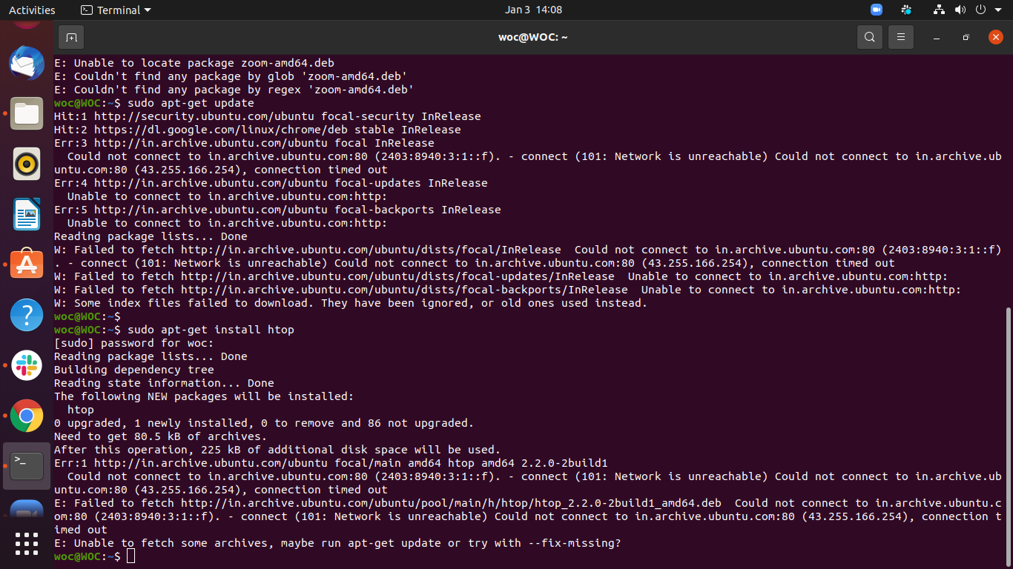

**=> OpenSSH — sudo apt-get install openssh-server**

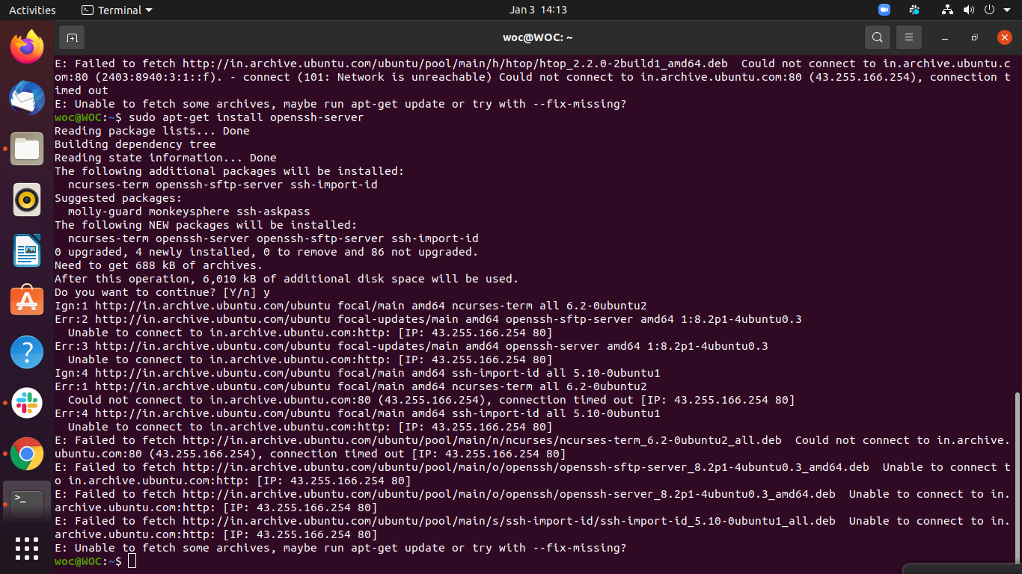

**=> nano — sudo apt install nano**

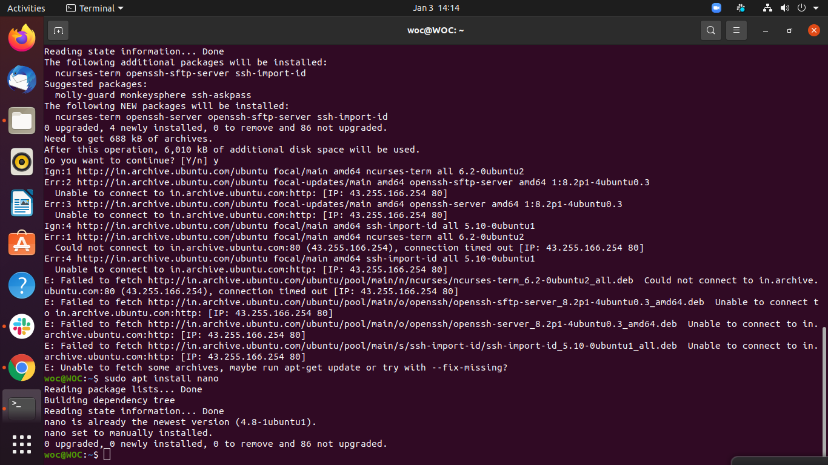

* **Create a folder**

**mkdir**

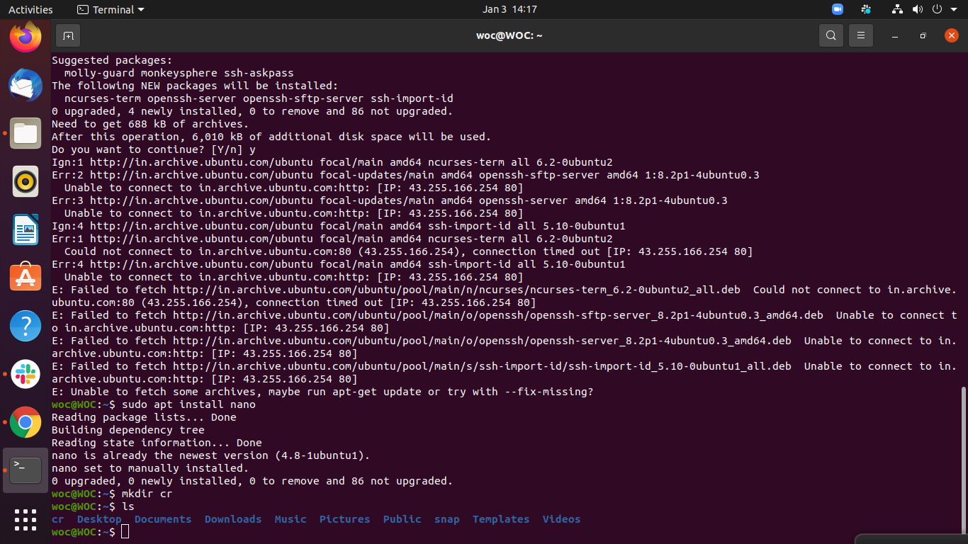

* **Create one file add 100’s of lines inside**

**Touch test1.txt**

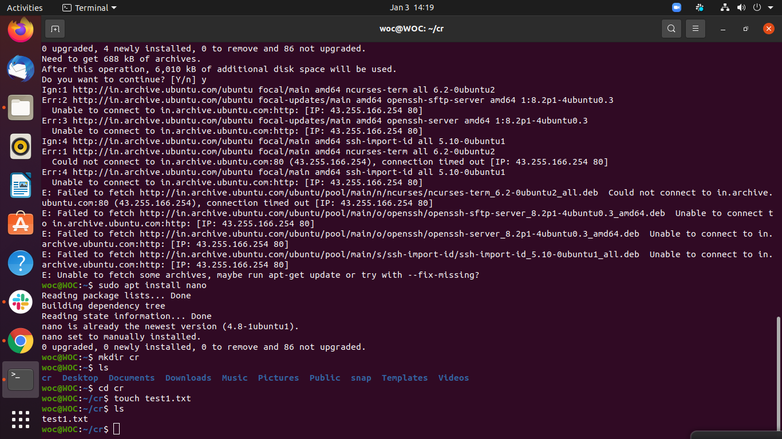

* **Create a copy of the file with _copy.txt in name**

**Cp test1.txt demo.txt**

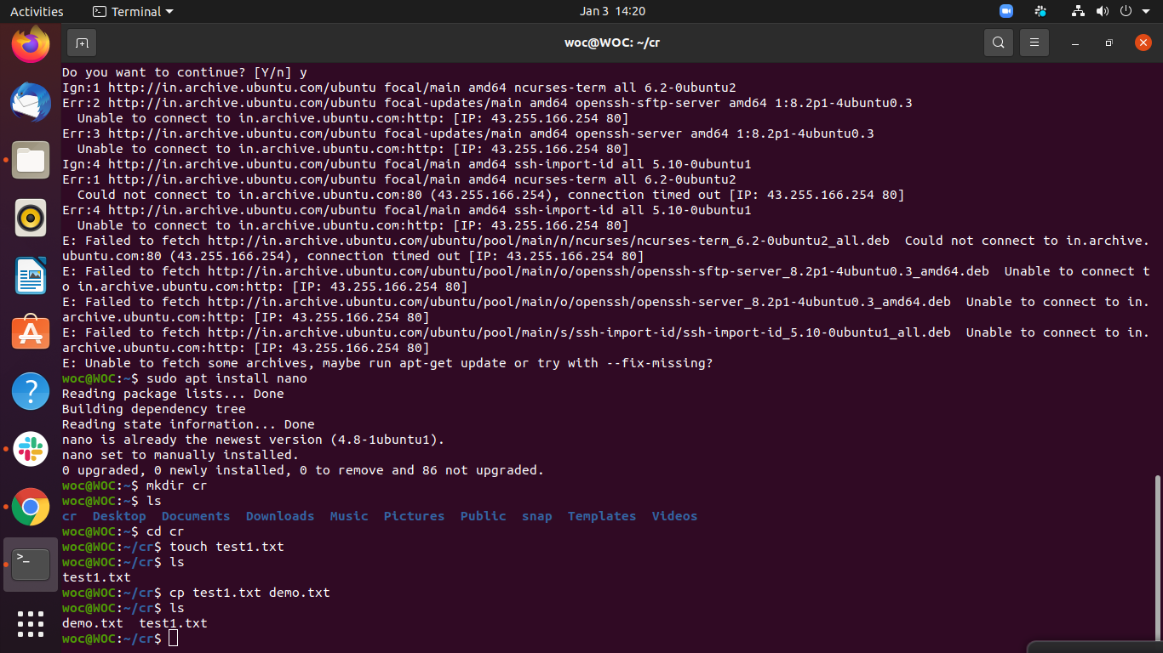

* **Try head and tail**

**Head test1.txt**

**Tail test1.txt**

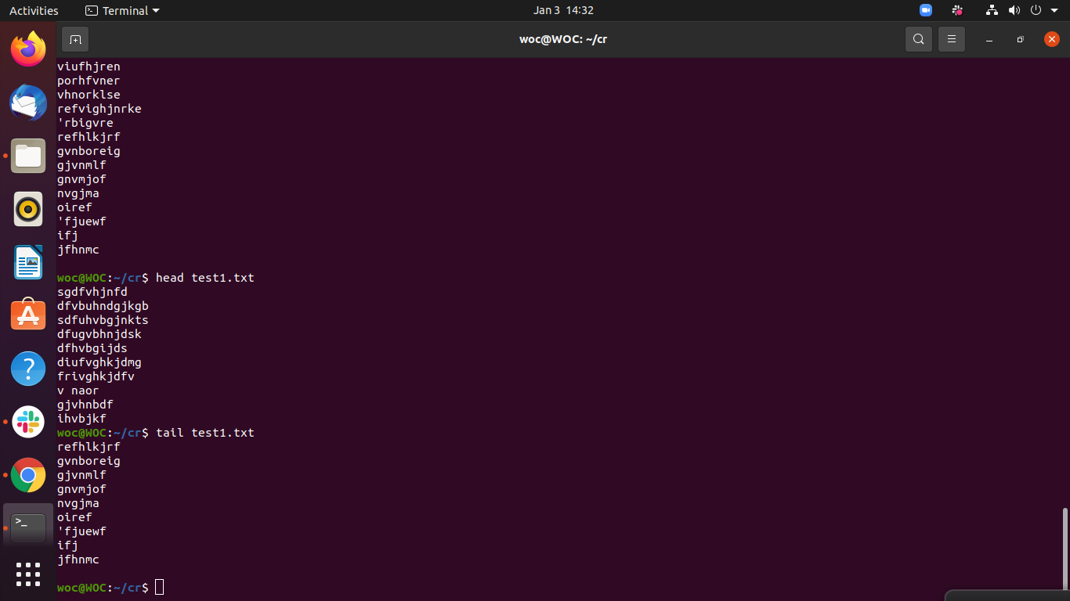

* **Add current path of inside file inside Task 3 file at the end.**

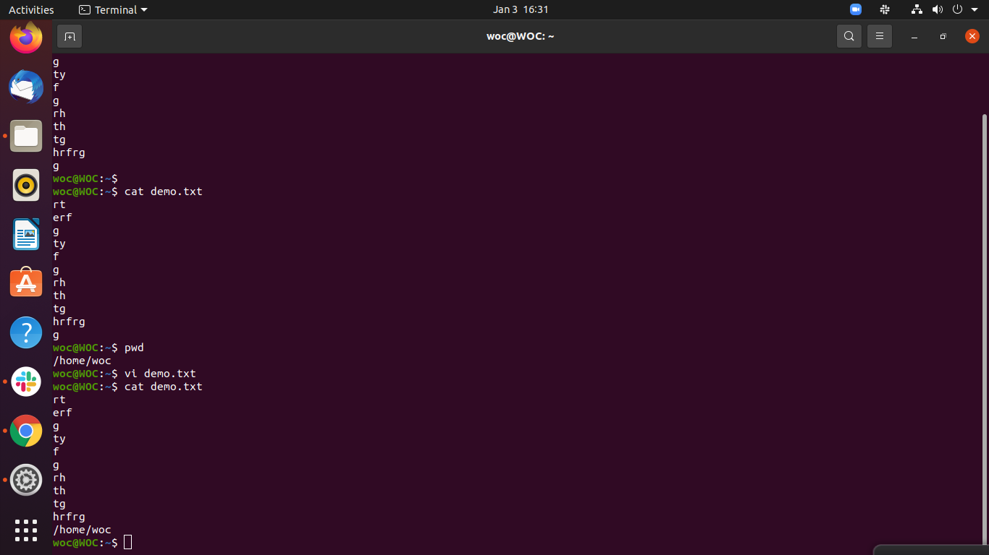

* **Create a file without opening**

**Touch show.txt**

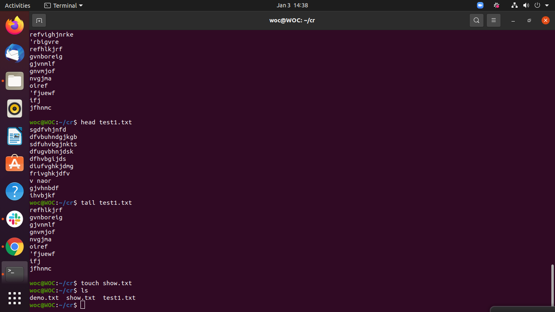

* **Rename all 3 files**

**mv test1.txt test.txt**

**mv show.txt data.txt**

**mv demo.txt tech.txt**

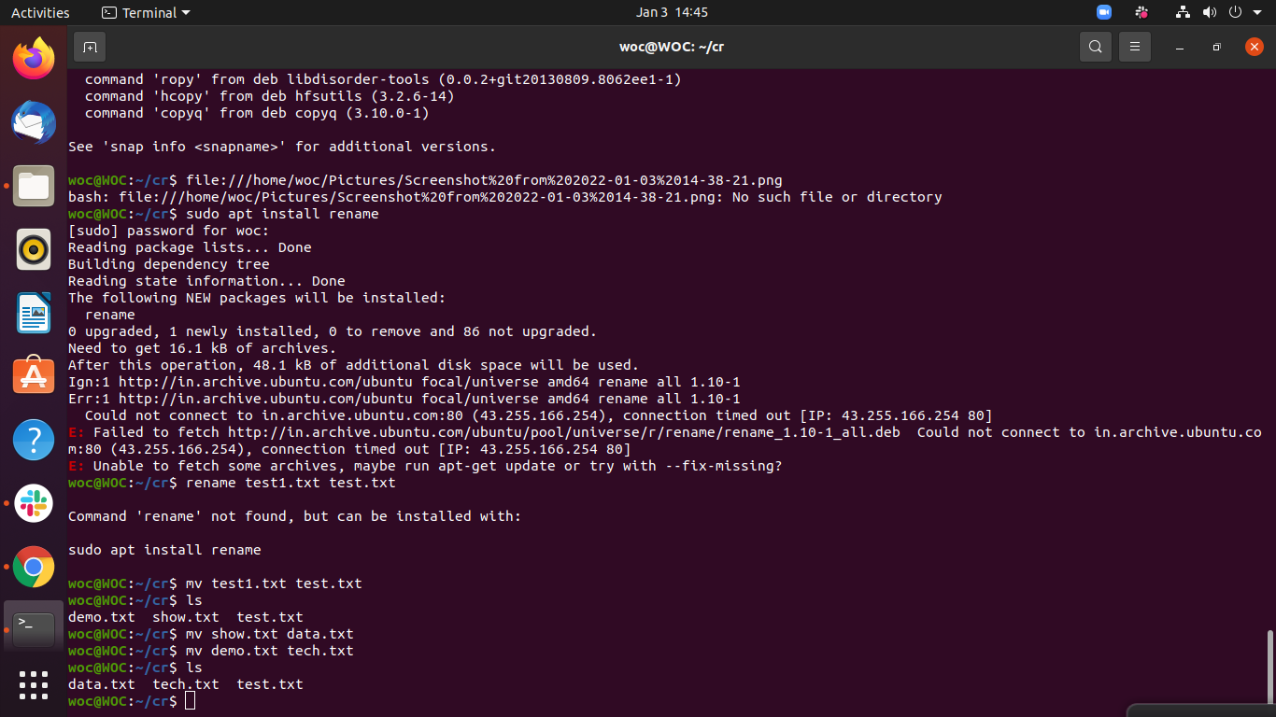

* **Delete all the files containing _copy.text at the end**

**rm test.txt data.txt tech.txt**

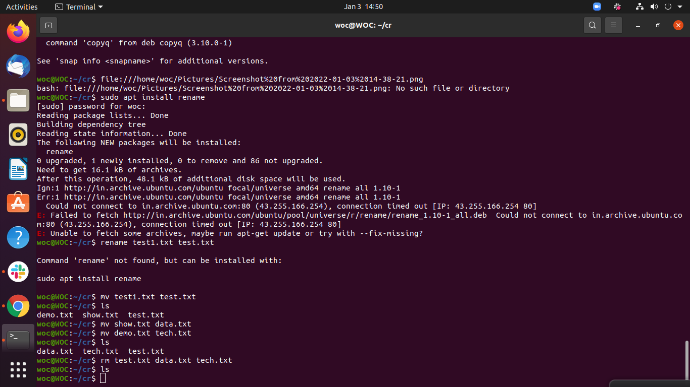

* **Check all the running processes**

**ps -aux**

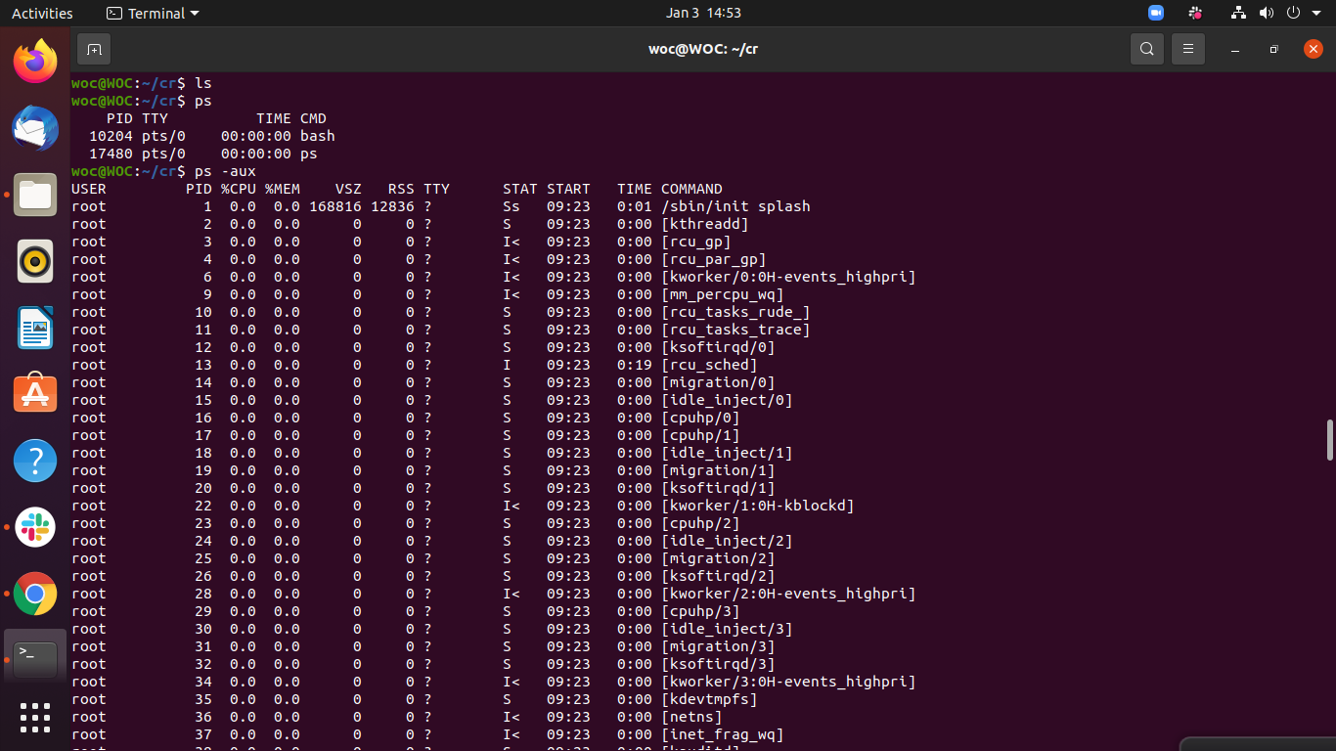

* **Find the location of the python**

**find python**

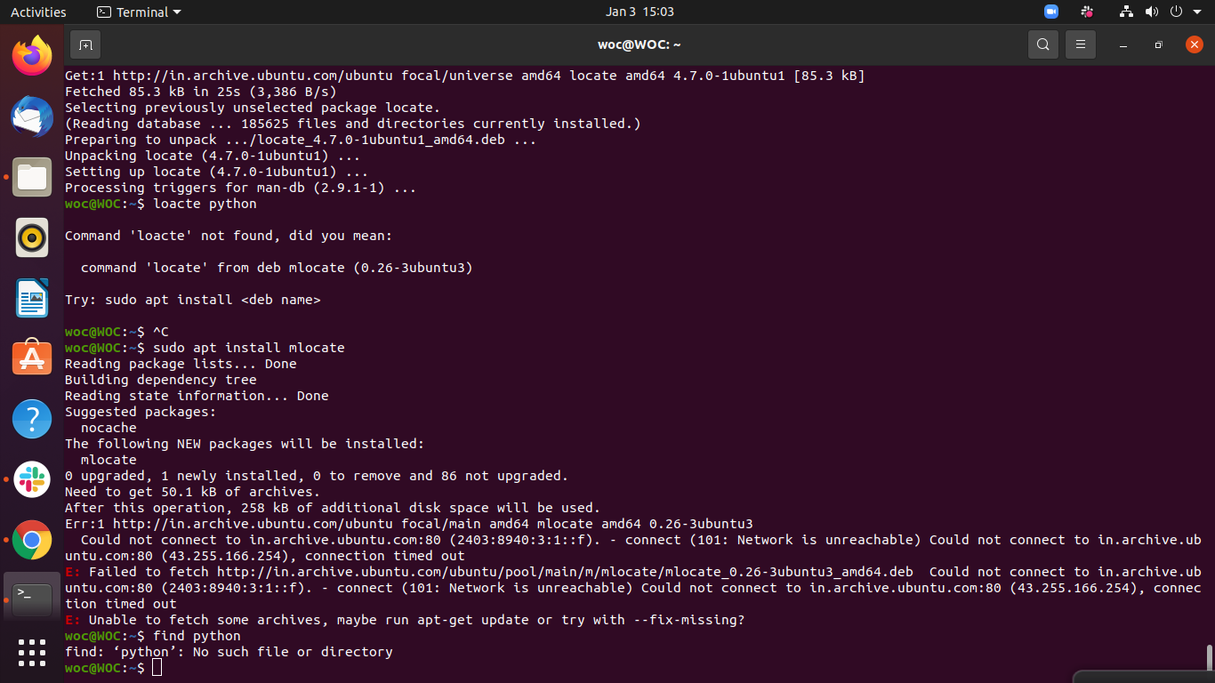

* **Check your current IP address and share it to a friend**

**systemd -resolve - - status | grep current**

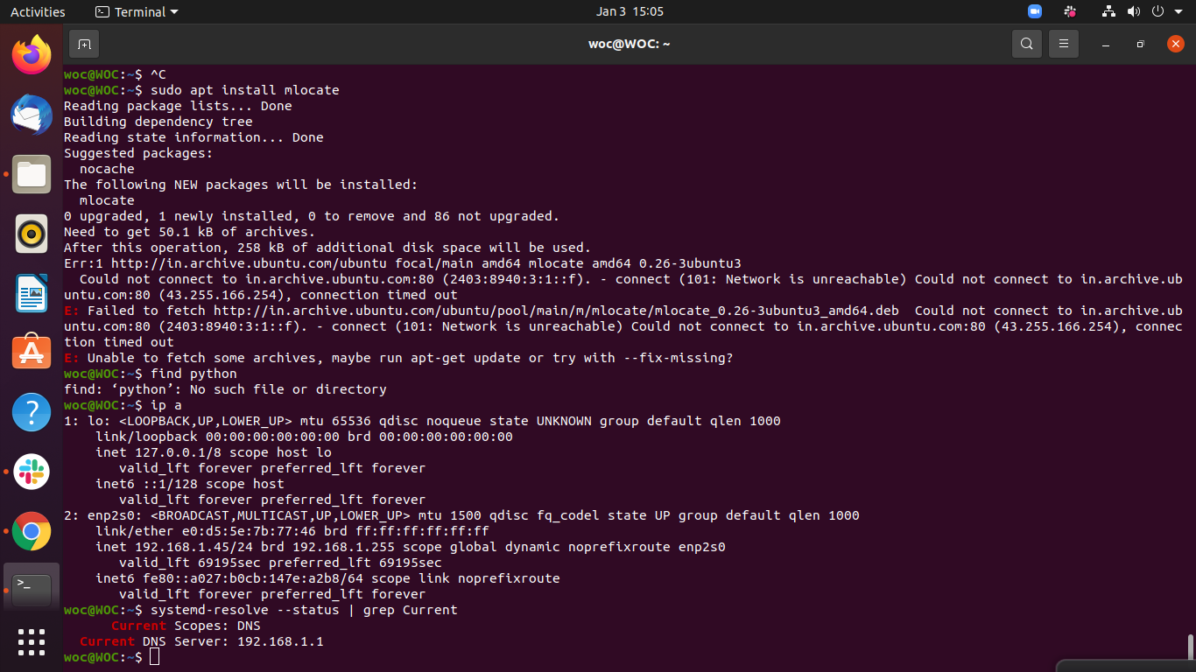

* **Check IP address of** [**weboccult.com**](http://weboccult.com/)

**host weboccult.com**

